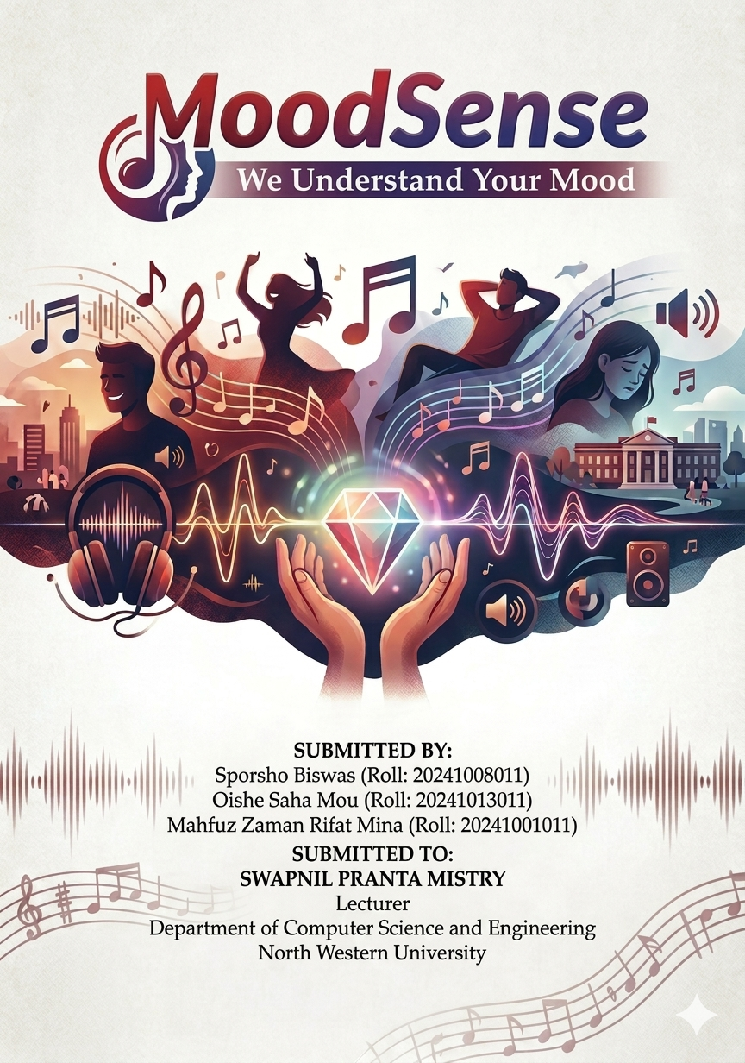

Project Title:
MoodSense – A Mood Based Interactive Web Application

Project Description:
MoodSense is a web-based interactive application designed to detect and respond to user moods through a simple and engaging interface. The system allows users to register, log in, and select their current mood such as happy, sad, motivated, or relaxed. Based on the selected mood, the application dynamically provides motivational quotes, music suggestions, and visual theme changes.The platform aims to enhance user emotional experience by offering personalized content in real time. It also includes a simple authentication system and backend integration for storing user data and mood history.MoodSense is designed to be lightweight, responsive, and user-friendly, making it suitable for learning full-stack web development fundamentals.

Tools and Technologies:
The MoodSense web application will be developed using modern web technologies to ensure simplicity, responsiveness, and scalability.

Frontend Development:
• HTML – For structuring web pages
• CSS – For styling and UI design
• JavaScript – For dynamic behavior and interactivity

Backend Development:
• Node.js – For server-side runtime environment
• Express.js– For handling APIs and routing
• In-Memory Storage / Simple Data Handling – For storing temporary user and mood data (beginner-friendly approach)

Security & Authentication:
• Basic Login & Signup System
• Password validation (simple implementation)
• Session handling using localStorage / server memory

Version Control:
Git & GitHub – For code management and tracking changes

Deployment:
• Local server deployment using Node.js
• Future scope includes cloud deployment (e.g., Vercel / Render)

Project Plan:
Week 1 :
• Define project requirements and scope
• Research mood-based web applications
• Set up GitHub repository

Week 2 :
• Install development environment (Node.js, npm)
• Create project folder structure
• Design UI wireframes

Week 3 :
• Develop frontend pages (Login, Signup, Home)
• Implement basic CSS styling
• Create responsive layout

Week 4 :
• Set up Node.js and Express server
• Create basic backend structure
• Connect frontend with backend

Week 5 :
• Implement user registration and login system
• Add form validation
• Store user data (simple storage system)

Week 6 :
• Develop mood selection system
• Implement dynamic quote and music suggestion feature
• Add mood-based UI changes

Week 7 :
• Integrate frontend with backend APIs
• Improve data handling logic
• Add logout functionality

Week 8 :
• Perform system testing and debugging
• Improve UI/UX design
• Optimize application performance

Week 9 :
• Conduct user testing
• Fix bugs and improve stability
• Enhance interactive features

Week 10 :
• Prepare final documentation
• Final testing and quality assurance
• Project submission and presentation preparation

Conclusion:
MoodSense is a beginner-friendly full-stack web application that helps users explore emotional interaction through technology. It provides a simple yet effective way to understand frontend and backend integration. The project is scalable and can be further enhanced with advanced features such as AI-based mood detection and database integration.

